# Deep Q-Learning Image Results:

Hyper parameters:

Epsilon = 0.95

Epsilon Decay Rate = 0.99

Discount Factor = 0.9

Learning Rate = 0.001

Memory Size = 10000

Batch Size (Experience Replay) = 24

Target Q-Network Update Iterations = 240 or 1

Goal State Reward = 100  
Wall State Reward = -1  
Time Step Reward = -1 (No Walls)

Time Step Reward = -0.1 (Walls)

### Experience Replay + Fixed Target Q-Network (1 Iteration) + Double DQN’s (No Walls):

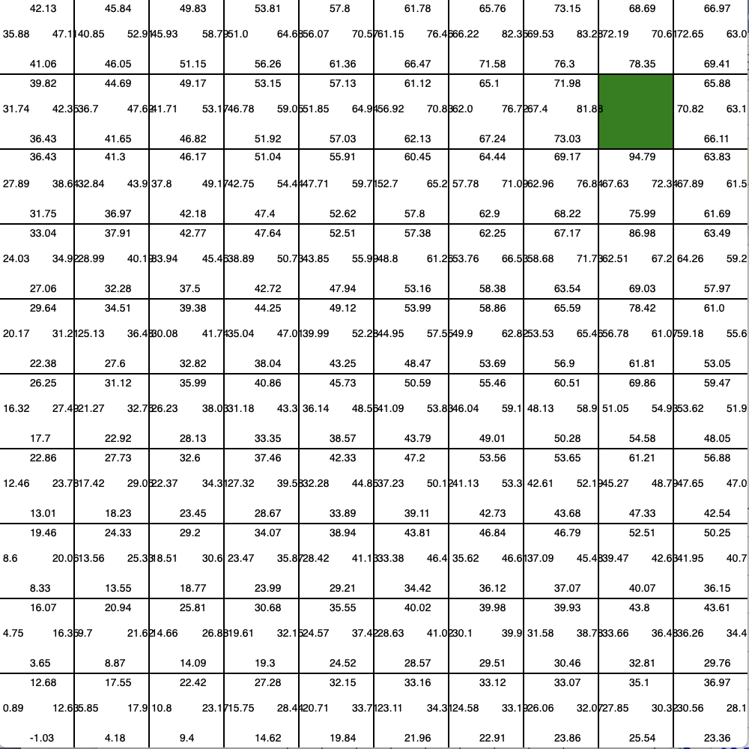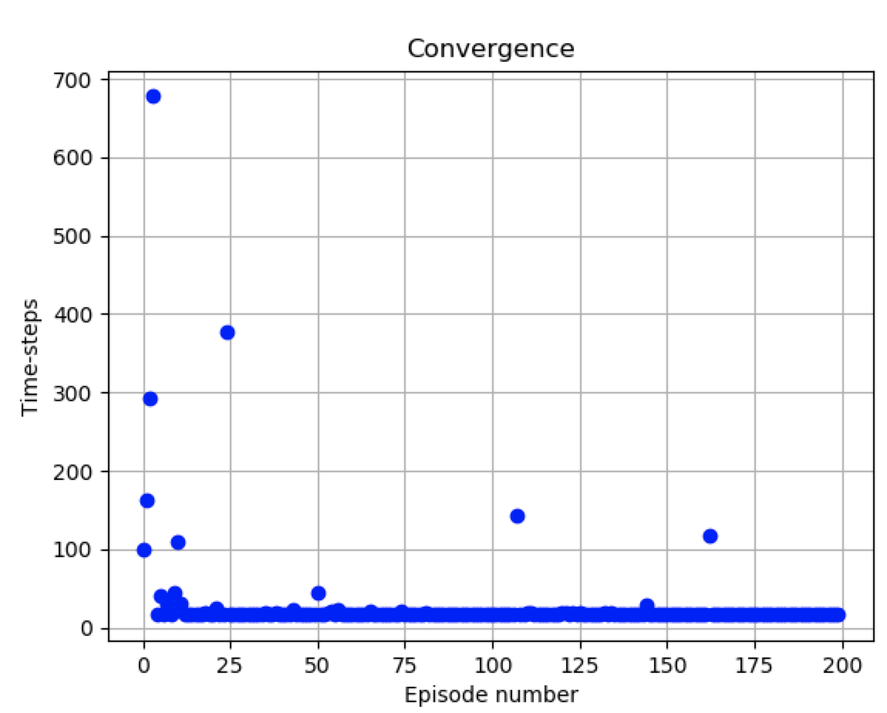

### Experience Replay + Fixed Target Q-Network (1 Iteration) (No Walls):

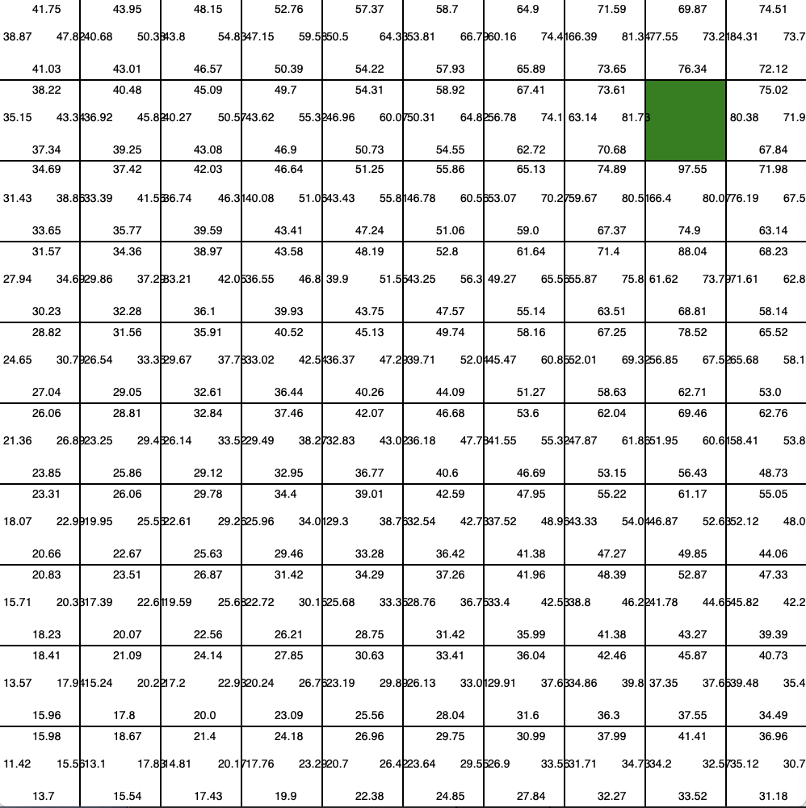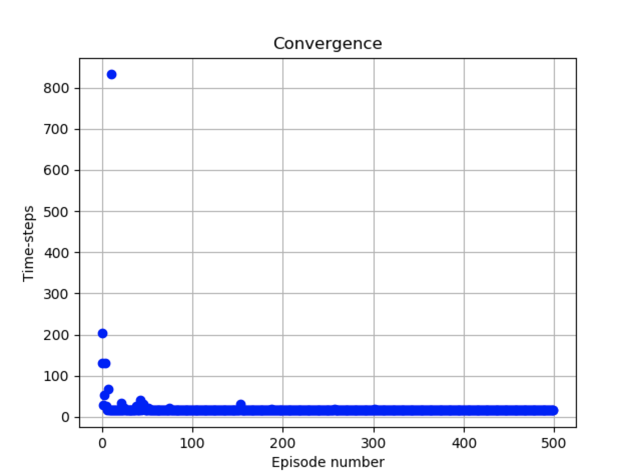

### Experience Replay (No Walls):

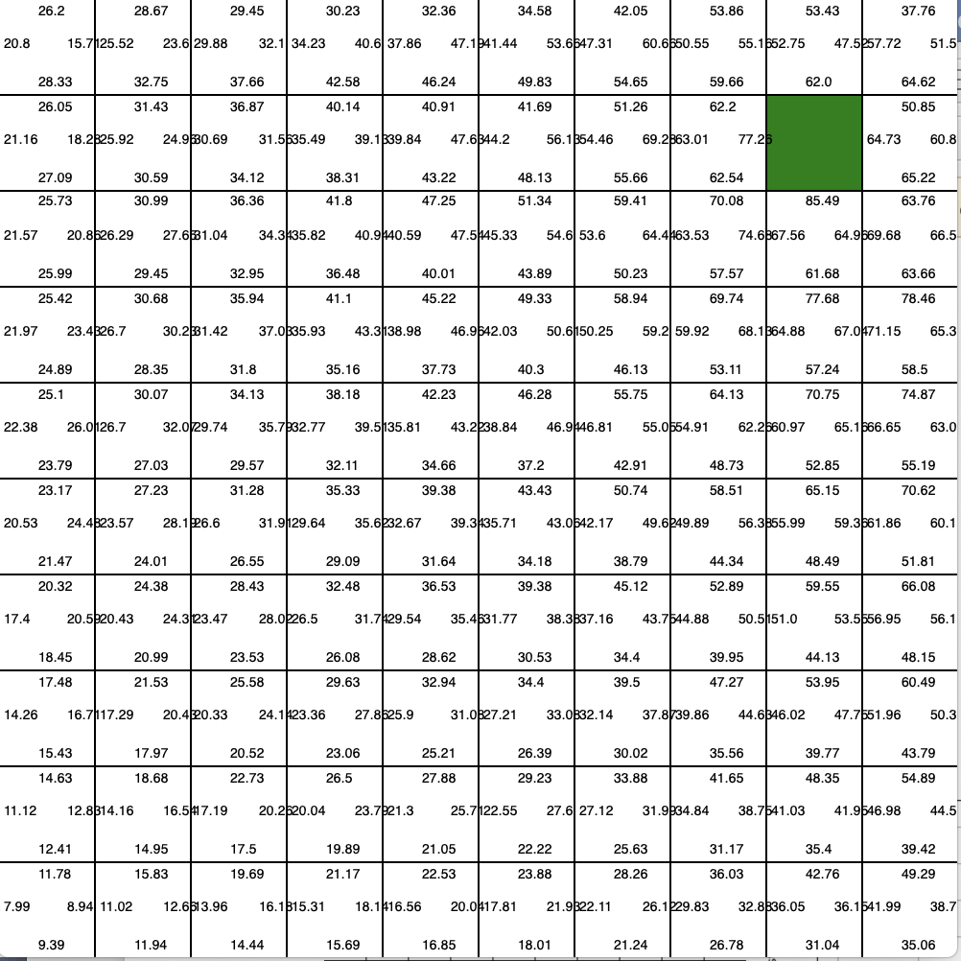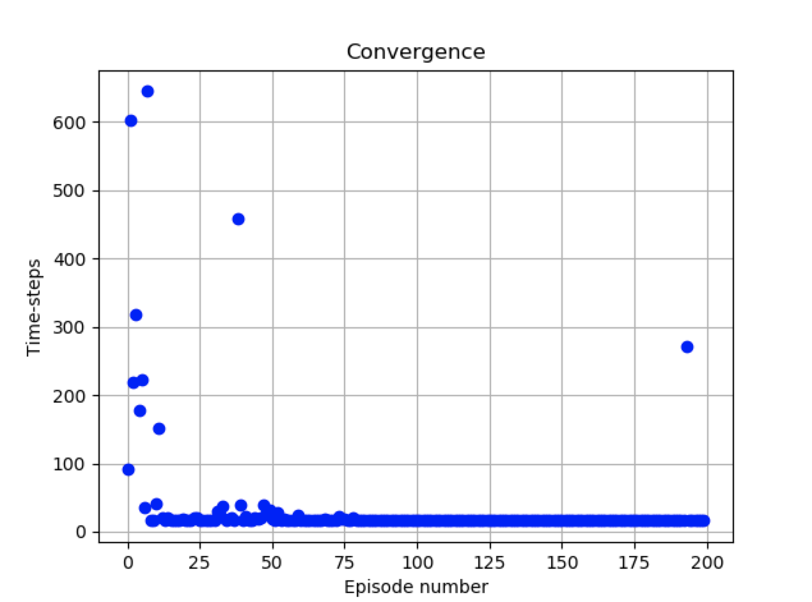

### Experience Replay + Fixed Target Q-Network (1 Iteration) + Double DQN’s (1 Wall):

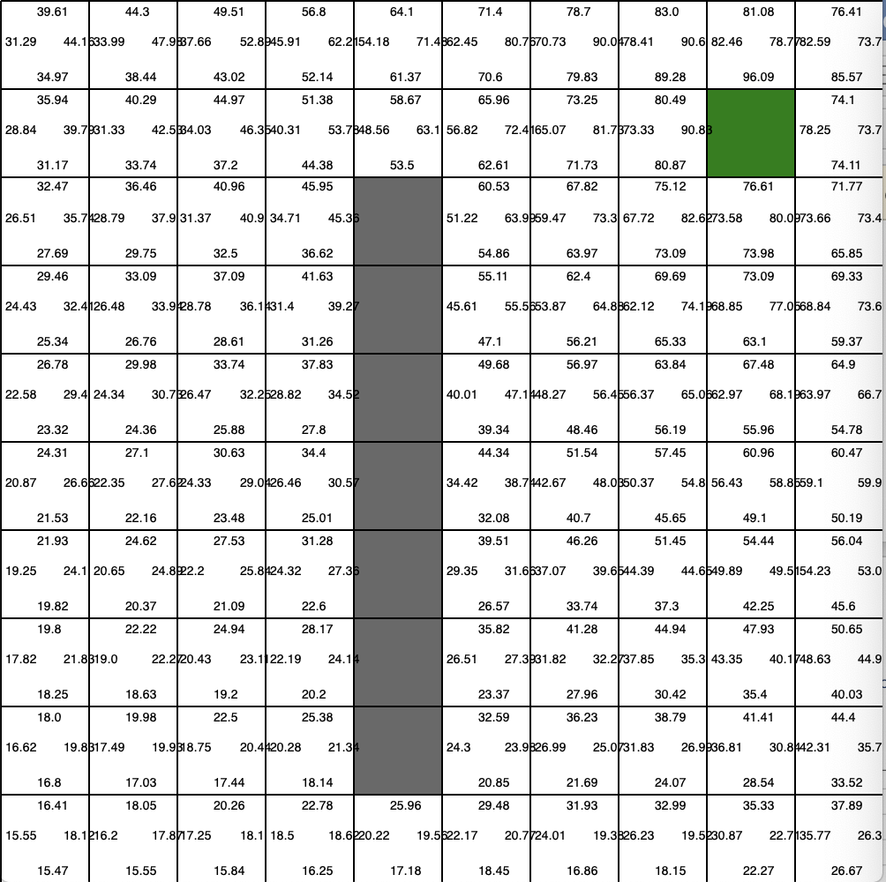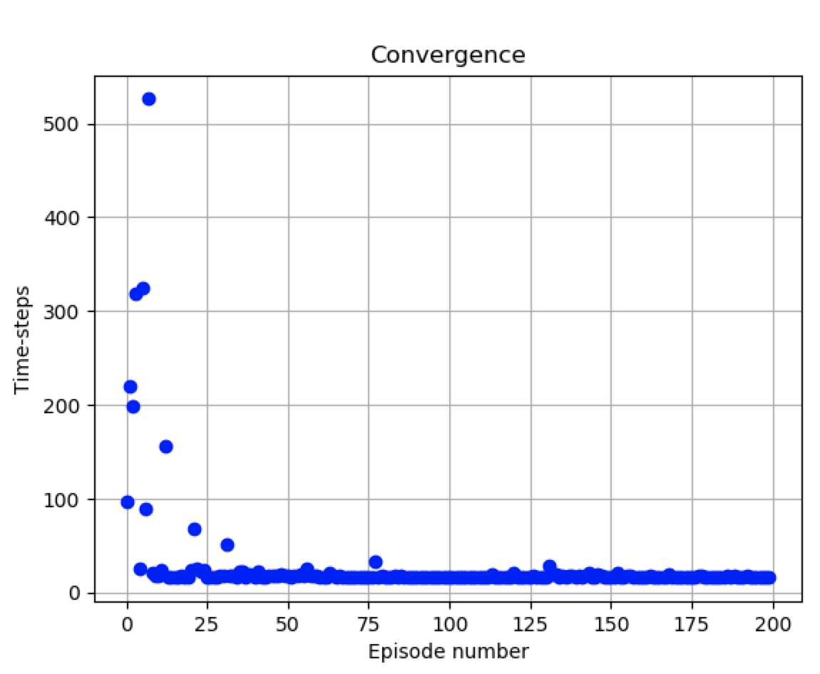

### Experience Replay + Fixed Target Q-Network (1 Iteration) (1 Wall):

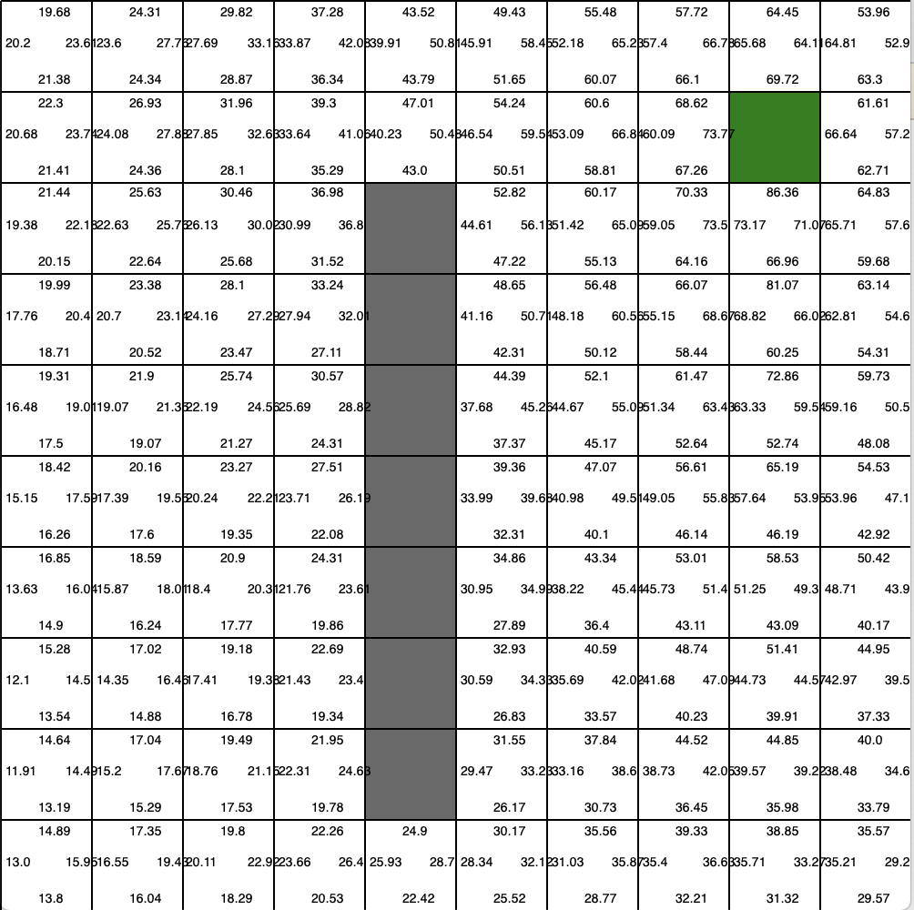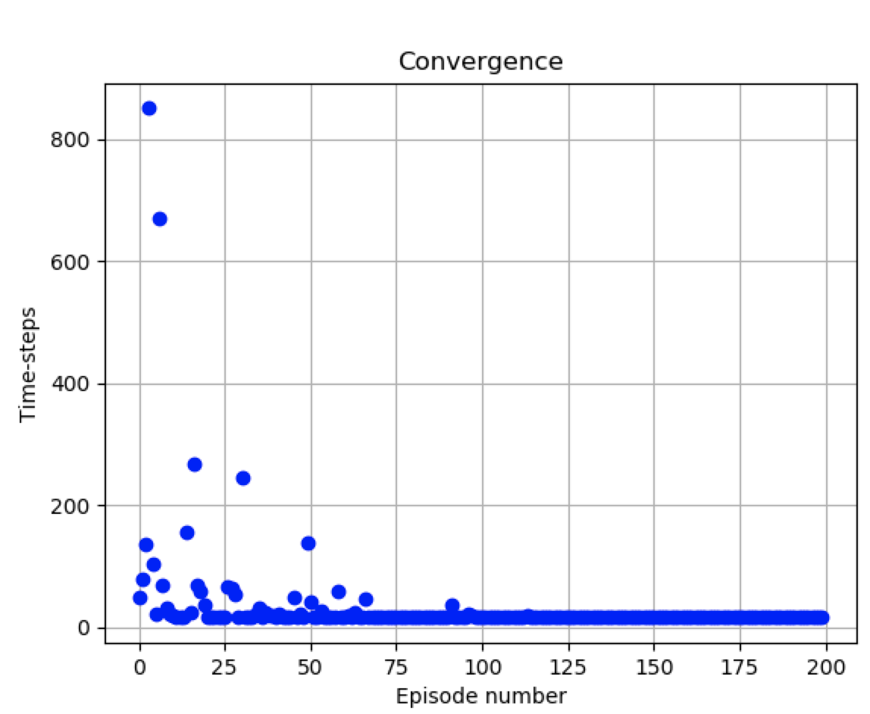

### Experience Replay (1 Wall):

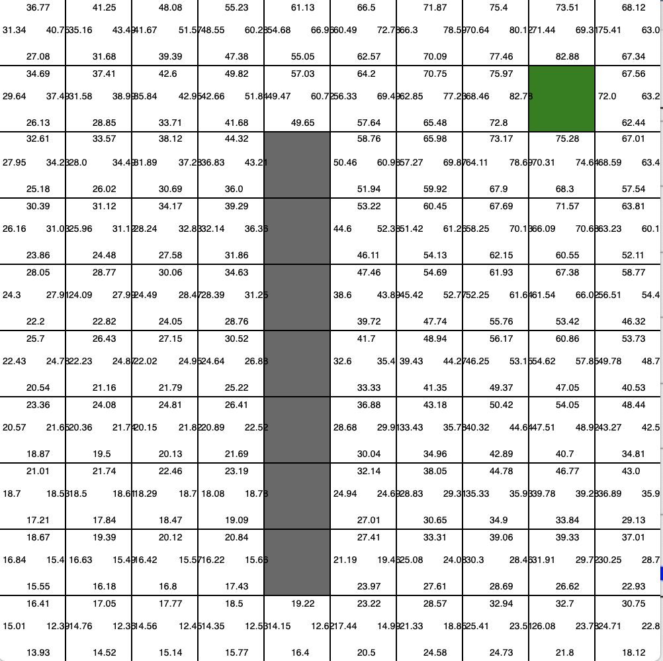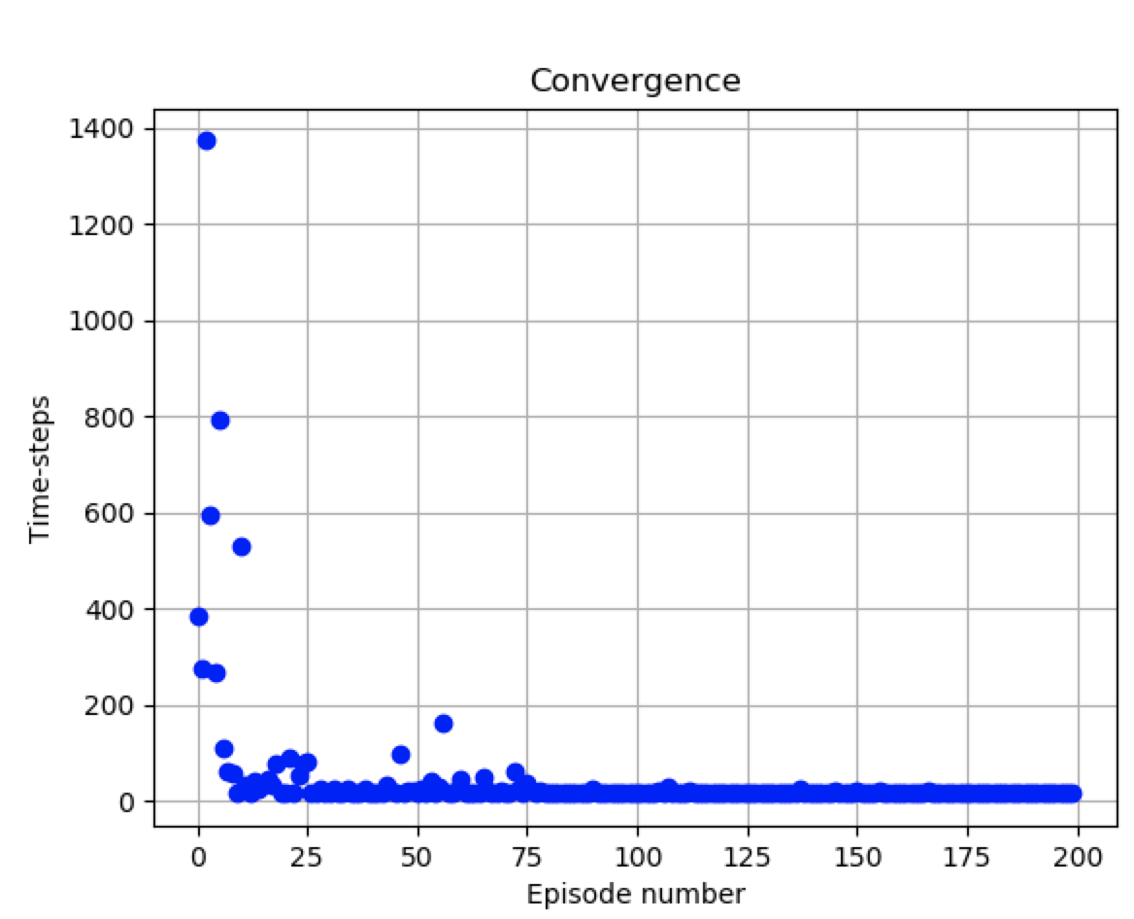

### Experience Replay + Fixed Target Q-Network (1 Iteration) (Walls):

